Table Rock Pharmacy COVID-19 Oral Antiviral Workflow Policy and Procedures

Policy:
This document provides guidance for COVID-19 oral antiviral prescription analysis and workflow.

Procedures:

Helpful Resources:
Internal Purposes:
- CPESN COVID-19 Oral Antiviral Guide
- NCPA COVID-19 Antivirals Dispensing and Reimbursement
- VPoP (to record inventory daily)
External Purposes:
- NCDHHS Therapeutics locator tool (to find sites that have inventory in stock)
- NC Patient Prioritization Communication January 4, 2022
- NIH Patient Prioritization Criteria
- CDC Underlying Conditions Associated with Higher Risk for Severe COVID-19
Product Specific:
- Paxlovid Provider Fact Sheet
- Paxlovid Patient Fact Sheet (click here for Spanish)
- FDA Molnupiravir Prescriber Checklist
- Molnupiravir Provider Fact Sheet
- Molnupiravir Patient Fact Sheet (click here for Spanish)

Pharmacist Responsibilities:
General:
- Dispense the oral covid-19 antiviral therapy with a valid prescription from a physician, advanced practice registered nurse, or physician assistant per the FDA EUAs.
- Verification of time since symptom onset. Patient needs to start therapy within 5 days of symptom onset.
- Provide patient counseling for the oral antiviral product being dispensed (see table at the end of this document for common side effects, etc.). To limit exposure to the patient, call the patient before they arrive and counsel them over the phone. Ask that they call us when they arrive, stay in their car and wear a face mask.
- Provide Antiviral Fact Sheet for the Patient (print out and bag with prescription).
- Report adverse events and medication errors to FDA MedWatch (details follow).
- Document course inventory and administration numbers daily within VPoP (details follow).

Patient Prescription Details:
- Prescriber is supposed to have fill by date on the prescription or noting on the prescription how many days the patient is into symptom onset. If not, call the provider’s office to get this information and add it to the prescription.
- We request that prescriptions for either medication include:
  - Symptom onset date (both medications must be started within 5 days of symptom onset)
  - Date of positive COVID test
  - What qualifies the patient as high-risk

Specific Medication Considerations - Paxlovid:
- Ask the provider’s office and/or patient for a current medication list. Using eFacts, or another resource, run a drug interaction check. Counsel patients appropriately (e.g. not starting Paxlovid until 12 hours after the last dose of simvastatin and holding simvastatin for the duration of Paxlovid therapy).
- Remove tablets if the patient has moderate renal impairment (prescriber is responsible for notating renal dosage adjustment on prescription).

Specific Medication Considerations - Molnupiravir:
- Females of childbearing potential treated: should use a reliable method of contraception correctly and consistently, as applicable, for the duration of treatment and for 4 days after the last dose of molnupiravir.
- Males of reproductive potential treated: if sexually active with females of childbearing potential, should use a reliable method of contraception correctly and consistently during treatment and for at least 3 months after the last dose.

Required Reporting for Serious Adverse Events and Medication Errors:
Note: Review each Fact Sheet for a list of serious adverse events

Submit adverse event and medication error reports, using Form 3500, to FDA MedWatch using one of the following methods:
- Complete and submit the report online: Click here.
- Complete and submit a postage-paid FDA Form 3500 (click here) and return by: Mail to MedWatch, 5600 Fishers Lane, Rockville, MD 20852-9787, or Fax to 1-800-FDA-0178.
- Call 1-800-FDA-1088 to request a reporting form.

Additional steps for each product for reporting serious adverse events and medication errors:
- Molnupiravir: In addition, provide a copy of all FDA MedWatch forms to: Merck Sharp & Dohme Corp., a subsidiary of Merck & Co., Inc., Kenilworth, NJ USA Fax: 215-616-5677 E-mail: dpoc.usa@msd.com
- Paxlovid: In addition, provide a copy of all FDA MedWatch forms to Pfizer: www.pfizersafetyreporting.com; Fax #: 1-866-635-8337; Telephone #: 1-800-438-1985

Instructions for Inventory/Administration Reporting for # of Courses:
- Each pharmacy is required to report COVID-19 antiviral therapy inventory daily within VPoP.
- Enter the daily courses administered and courses available by clicking the white box and typing in a number value (see screenshot below). The column cell appears with a blue corner to indicate unsaved data.
- Click “Save Therapeutic Courses'' and you will see a success message at the top of the page.
- Example: On Day 1: The pharmacy receives 20 courses of molnupiravir and enters “20” in Courses Available. On Day 2, the pharmacy dispenses molnupiravir to 5 patients. At the end of Day 2, enter “5” in Courses Administered and “15” in Courses Available. At the end of Day 3, you can continue to enter the new number for courses available and courses administered. The History field will automatically update and will contain the previously entered information.

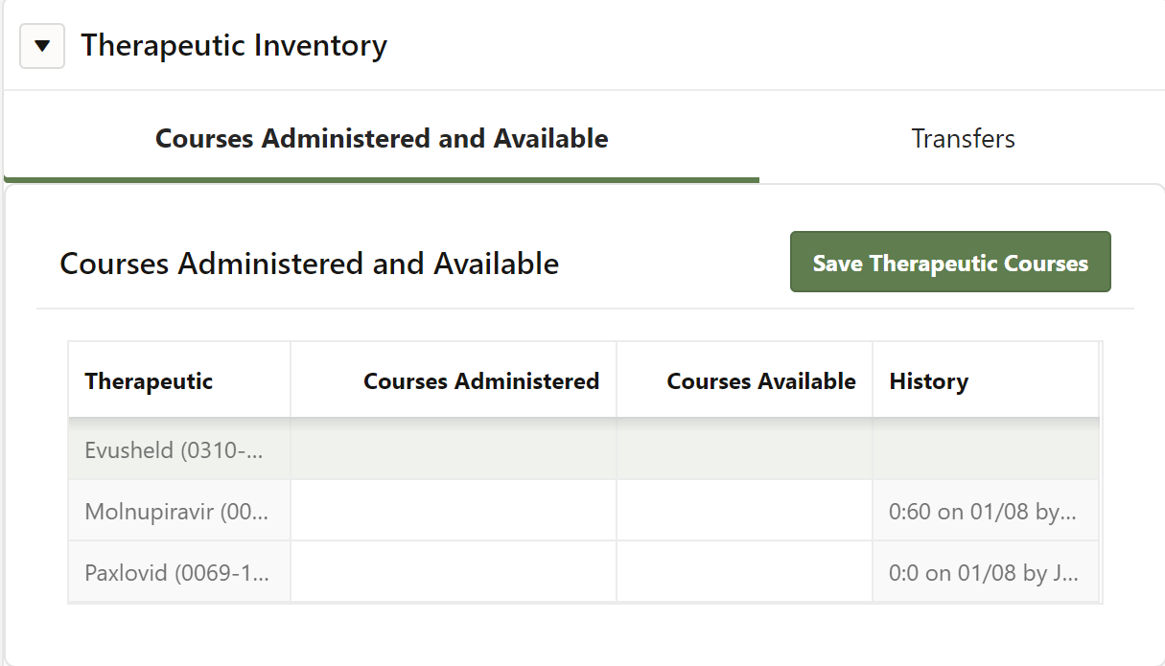

COVID-19 Oral Antiviral Comparison Chart
 | Paxlovid | Molnupiravir
Age | 12+ | 18+ (bone/cartilage damage in peds)
Indication | Treatment of mild-to-moderate COVID-19 (not post-exposure prophylaxis) in those at high-risk of developing severe COVID (must start w/in 5 days of symptom onset) | Treatment of mild-to-moderate COVID-19 (not post-exposure prophylaxis) in those at high-risk of developing severe COVID (must start w/in 5 days of symptom onset)
Dose/Administration | 300mg nirmatrelvir (two 150mg tablets) with 100mg ritonavir (one 100mg tablet) - all three tablets taken together every 12 hours for 5 days with or without food | 800 mg (four 200 mg capsules) taken orally every 12 hours for 5 days with or without food
Renal Dose Adjustment | Yes - eGFR ≥30 to <60 mL/min: 150 mg nirmatrelvir (one 150 mg tablet) with 100 mg ritonavir (one 100 mg tablet); eGFR <30: not recommended | No
Quantity | 30 tablets | 40 capsules
MOA | Nirmatrelvir inhibits a COVID-19 protein to stop the virus from replicating; ritonavir slows down nirmatrelvir’s breakdown to help it remain in the body for a longer period at higher concentrations. | Incorporates into the viral DNA, causing viral errors, which stops the virus from replicating.
Contraindications | Co-administration with certain CYP3A medications (e.g. alfuzosin, amiodarone, simvastatin, colchicine, midazolam), significant hypersensitivity to either drug | None
Drug Interactions | Several (reference EUA Fact Sheet for guidance on each) | None identified
Warnings | Several drug interactions, potential for hepatotoxicity, HIV-1 drug resistance | Embryo-fetal toxicity: not recommended for use during pregnancy (must use effective contraception for  duration of treatment and for 4 days after the last dose), bone and cartilage toxicity: not authorized for use in patients less than 18 years of age because it may affect bone and cartilage growth
Adverse Reactions | Dysgeusia (distorted sense of taste), diarrhea, hypertension, and myalgia | Diarrhea, nausea, and dizziness
Missed Dose | Within 8 hours of scheduled dose: take  >8 hours of scheduled dose: skip | Within 10 hours of scheduled dose: take  >10 hours of scheduled dose: skip

